Technology Manager for Administrators Job Aids

Table of Contents

Technology Manager Job Aids 1

Getting Started 3

Overview of Technology Manager 3

What is Technology Manager? 3

Accessing Technology Manager 3

Additional Help 4

Technology Manager User Roles 6

New User 7

Systems IDs 13

How do System IDs compare to a User ID? 13

My web page

# Technology Manager Job Aids

Technology Manager Job Aids are a fully searchable set of task-based instructions and other information that helps you perform the most commonly-used functions within the Technology Manager application.

Here are some tips for using the job aids:

* Sets of job aids are grouped under book icons (book icon.gif). Click a book icon to reveal its topics.
* Individual job aid topics are designated with a page icon (page icon.gif) in the navigation panel.
* Enter a topic into the **search field**  to search for a particular word or phrase throughout the entire set of job aids. Job aids in which your search term is found are displayed. When you click on a topic resulting from a search, your search term is highlighted within the job aid itself.
* Click **Print** to print the currently selected topic.
* Click **Hide** to close the navigation panel, and click **Show** to redisplay the navigation panel.

Back to Top

© 2018 Fannie Mae. Trademarks of Fannie Mae.

# Getting Started

My web page

## Overview of Technology Manager

### What is Technology Manager?

Technology Manager is an application that allows Fannie Mae lenders to manage user access of Fannie Mae technology applications.

Below are some of the functions that can be performed in Technology Manager:

* **Manage applications:**  Registering an organization for an application, setting up an application, and deleting an application
* **Manage company configuration:**Manage company information and timing of password expiration for users
* **Manage users:**Creating a new user, deleting a user, and managing user access to applications and data folders (data sets within an application)
* **Generate reports:**Generate, print, and export reports
* **Manage data folders:**  Editing data folders, and changing billing options, if applicable
* **Manage user groups:**  Creating user groups, editing user groups, and deleting a user group
* **Manage lender/broker relationships:**  Reactivating and deactivating relationships
* **Modify Security Information:** Editing password, PIN and security question and answer.

The functions that an individual can perform will depend on the assigned role.

## 

### Accessing Technology Manager

#### Log In to Technology Manager

1. Go to <https://technologymanager.efanniemae.com/selfservice>.

**Note:**  Alternatively, you can go to the [Technology Manager page](https://www.fanniemae.com/singlefamily/technology-manager) on the Fannie Mae Single Family Business Website and click the Launch App button.

1. The Technology Manager Log In screen appears. Enter the user ID and password you received from Fannie Mae, then click **Login**.  
     
   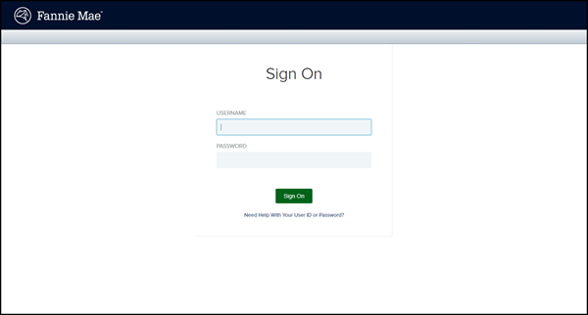

**Note:**  If you need assistance with your User ID or Password, click the **Need help with your user ID or password** link below the Login button.

### 

#### Log Out of Technology Manager

To log out of Technology Manager, click the Logout button at the top right hand corner of any page.    
  


### Additional Help

To access the Help Center within the Technology Manager application, click the **Help Center** link, which is found in the lower-right corner of any screen.  
  
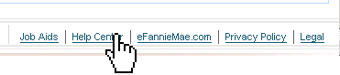  
  
The Help Center provides you with the following features:

* **Frequently asked questions** – View FAQs pertaining to the screen you are currently viewing. Click on the question to obtain a more detailed answer.
* **Search feature** – Enter a question relating to the screen you are currently viewing, and click **Find**.
* **Live Web Chat** – Submit a question and correspond online with a Customer Service Representative in Fannie Mae’s Customer Contact Center. To access this feature, select Open a Web Chat on the Technology Application Support page on the Business Portal and follow the instructions provided. Live Web Chat is available Monday through Friday from 9:00 a.m. to 8:00 p.m., Eastern Time and 10:00 a.m. to 5:00 p.m. on Saturday.

Back to Top

© 2018 Fannie Mae. Trademarks of Fannie Mae.

My web page

## Technology Manager User Roles

All Fannie Mae customers in all customer segments can use Technology Manager.  An individual can either have access as an End User (external technology user) or as an Administrator.

There are two types of Administrators: Corporate Administrators (CA) and User Administrators (UA). Each administrator has a set of permissions that identifies application(s), user group(s) and data folder(s) that can be assigned to users by that administrator.

Some companies may choose one individual to manage all users, while others may set up a hierarchical structure of administrators.  Regardless of the structure your company chooses, your own view of Technology Manager will list only those organizations, branch organizations, users, data folders, and applications that you are authorized to manage.

Your organization determines which role a person may have.

* **Corporate Administrators** have the ability to set up applications, data folders, user groups, users, and company configuration. These people also have signatory authority, serving as company representatives authorized to bind the company legally to the terms and conditions of use for Fannie Mae technology.
* **User Administrators** have the ability to set up and manage users' profiles and passwords, and access to Fannie Mae technology applications.
* **End Users** have access to Fannie Mae technology applications, but are not administrators.  Depending on the organization's password management settings, end users may be able to reset their passwords and update their profiles.

Back to Top

© 2018 Fannie Mae. Trademarks of Fannie Mae.

My web page

## New User

When your Technology Manager Administrator creates you as a new user, one of the emails you will receive is the Fannie Mae New User ID Confirmation Email. The email will contain a link for you to activate the new user ID.

To activate your new user ID

1. Click on the link in the email.  
     
   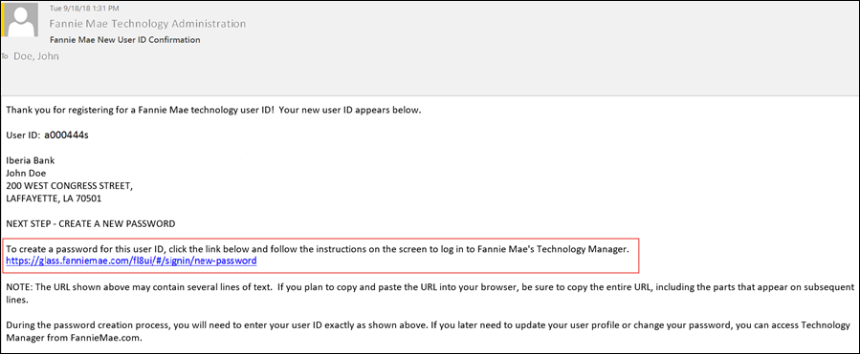
2. The *Enter your current user ID* screen appears. Enter your current user ID and click **Continue**.   
     
   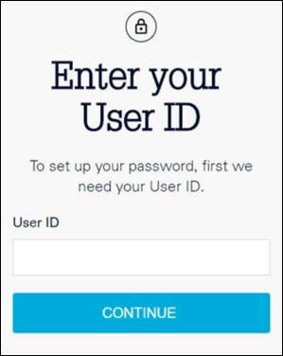  
     
   The *You Entered* screen appears and the system will send you a temporary passcode to the email in your profile.

**Note:** If your system is set up for the password to be managed by the Administrator, the temporary passcode will go to the administrator's email address. For more information, see the Password Administrator Information section of the Edit Your Profile Job Aid.

1. Check your email for a message from Fannie Mae with your temporary passcode. This passcode is valid for 30 minutes.

If you do not receive an email with the passcode:

* 1. Confirm the User ID that you entered is accurate.
  2. Confirm the email address on your User Profile with your administrator.
  3. If you have not received the passcode within 15 minutes, return to step 1 and try again.  
       
     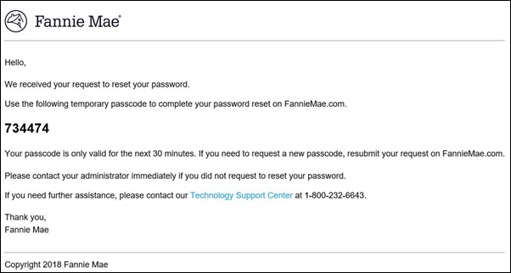

1. On the *You entered* screen, **enter the passcode** from the email and click **Submit Passcode**. The New Password screen appears.  
     
   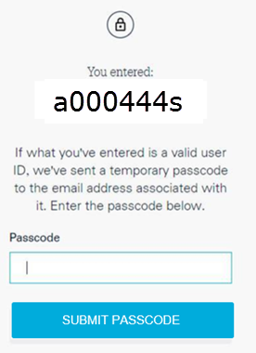
2. On the *New Password* screen, create a **password** per the criteria listed on the screen and enter the **password** again in the Confirm New Password text box. Click **Create Password.**  
     
   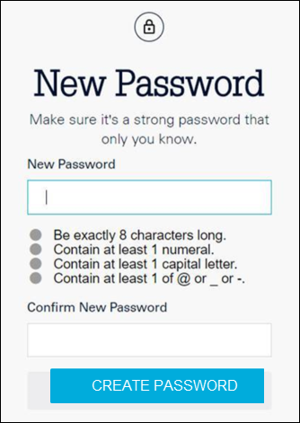
3. The *Success* screen appears. Click **Log in to TM** to complete the activation of your user ID.  
     
   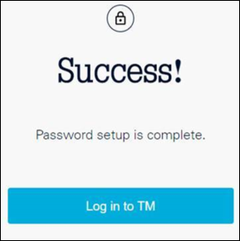
4. The Technology Manager Log In screen appears. Enter your user ID and the password that you set, then click Login



1. The *Edit My Profile* screen appears. Review your profile. See the Edit My Profile job aid for instructions on how to update your profile. Now you are ready to use the Fannie Mae applications granted to you by your administrator.

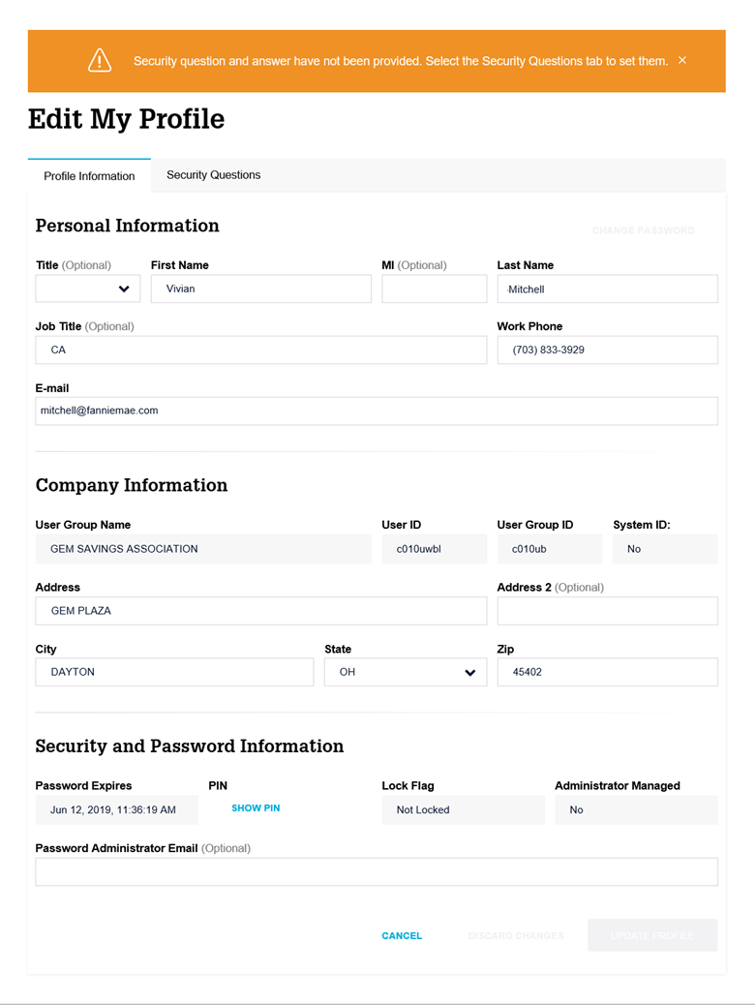

Back to Top

© 2018 Fannie Mae. Trademarks of Fannie Mae.

My web page

## Systems IDs

In Technology Manager, a User ID, which is unique for your systems, jobs, and processes, can be flagged as a System ID.  A System ID does not belong to one user and, once established, the password will never expire and the profile is never locked due to inactivity.

### How do System IDs compare to a User ID?

A normal User ID is set up for one specific user to have access to the applications needed to perform a specific role. The user password could expire every 90 days and could be locked due to 90 days of inactivity, depending on your company's security policy. A System ID is set up for the use of an organization's system, job or processes, the password never expires, and the profile is never locked due to inactivity.

See Managing System IDs and Resetting System ID Password job aids for more information.

Back to Top

© 2018 Fannie Mae. Trademarks of Fannie Mae.