Providing Files/Documents for a Single Loan Review

Table of Contents

Providing Loan Files and Documents for a Single Loan Review 1

What happens when a document is rejected by Fannie Mae? 5

My web page

# Providing Loan Files and Documents for a Single Loan Review

You can perform the actions needed to submit loan files and documents for review from your Request Queue or from Document Requests. You can track the status of document submissions and loan reviews from either screen as well.

**Note:** If a Document Request or Loan File Request has been issued in Loan Quality Connect, you will receive an Alert in the system. See Lender Action Alerts for more information about alerts.

Follow these steps to provide requested loan review documentation:

1. After logging in to Loan Quality Connect, select **Request Queue** or **Document Requests** from the left menu.  
   The screen opens showing the business intelligence (BI) cards at the top and a list of loans with summarized loan details below the BI cards.

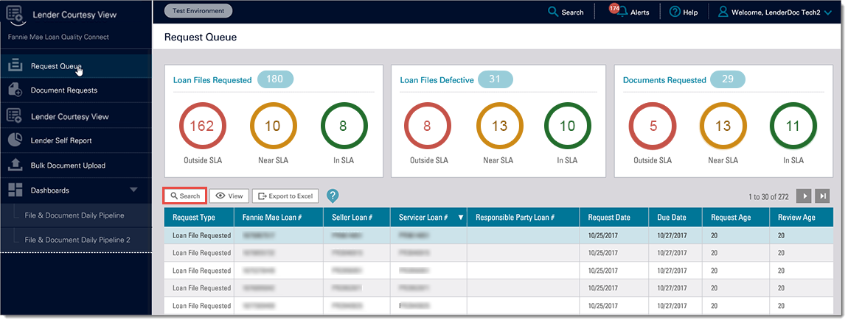

1. To find the request that you want to work on:
   1. Click a **BI card** and scroll through the filtered list of loans that displays below it, or
   2. Use the **Search** function in your work queue.
2. Select the request, and then click **View**. (Double-clicking the request will also open it.)  
     
   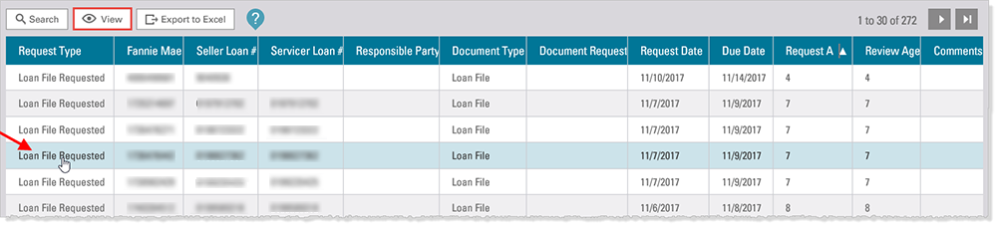  
     
   The Loan Details screen appears, displaying the loan review status bar and loan level details under the Summary tab.  
     
   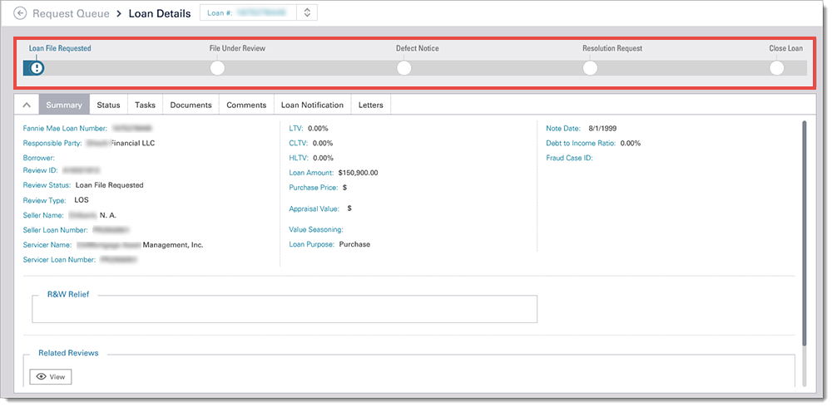
3. Hover over the exclamation point  Exclamation Point Icon icon on the loan review status bar to reveal details about the request.   
     
   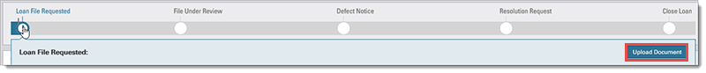

**Note**: When the loan is in Loan File Requested status, you can upload a document from the status bar by clicking**Upload Document***.*

1. Click **Tasks** toview the request. Requests are color-coded to indicate if they are *Complete* (green), *In Progress* (blue), or *New* (white).  
     
   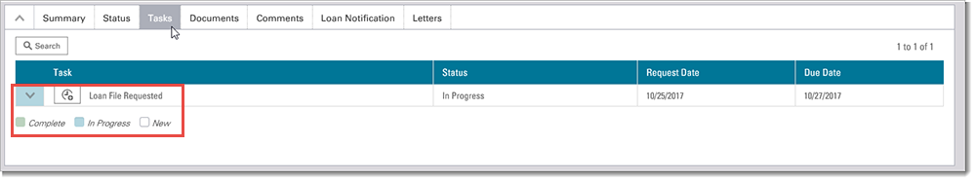
2. Click the **arrow** next to the request to open the outstanding tasks. Each task listed here has an icon menu next to it.  
     
   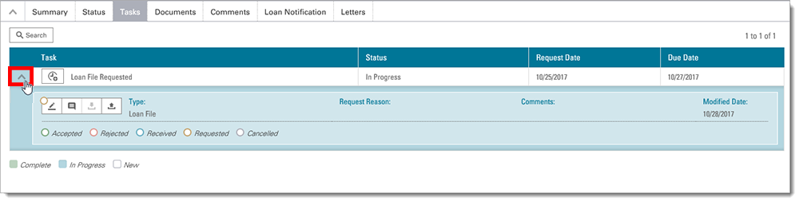
3. You can do four things in Tasks using the icon menu.

|  |  |
| --- | --- |
| **Edit a Document** Edit Document | **Add a Comment** Add Comment |
| **Download a Document** Download Document | **Upload a Document** Upload Document |

1. Notice that the outline of the circle at the upper left of the icon menu is color-coded to reflect the status of the request, either *Accepted* (green), *Rejected* (red), *Received* (blue), *Requested* (yellow), or *Cancelled* (gray).  
     
   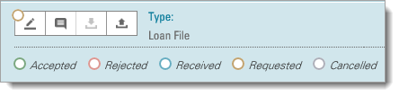

* **Accepted** means that the action you have taken on the task has been successfully submitted in Loan Quality Connect.
* **Rejected** means that the action you have taken on the task was rejected by the Loan Quality Connect system and you should try again.
* **Received** means that a Fannie Mae reviewer has received the information you submitted.
* **Requested** means that there is an outstanding request from a Fannie Mae reviewer for the information.
* **Cancelled** means that there was an outstanding request from a Fannie Mae reviewer for the information, but the task has been cancelled.

1. To provide a file for review, click the **Upload** icon.   
     
   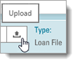  
   The Upload File window appears.
2. Click **Browse,** and thenselect a file to upload. Then click **Save**.   
     
   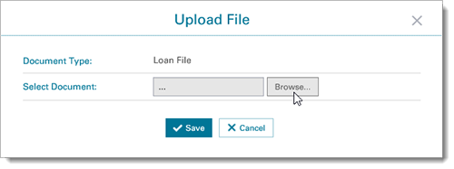

**Note:** A manifest is not required to upload documents to Loan Quality Connect.

1. The information displays, confirming the upload was successful. Click **Okay**.  
     
   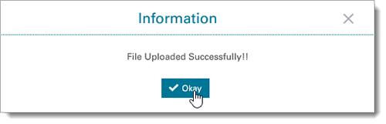
2. When you return to Tasks, this task has been removed from your queue.  
     
   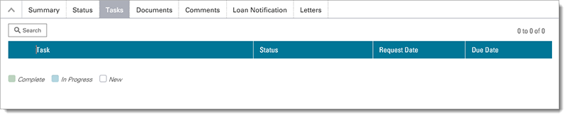
3. Click **Documents** to verify your loan file has been received. Note that the circle has changed to blue confirming the *Received* status.  
     
   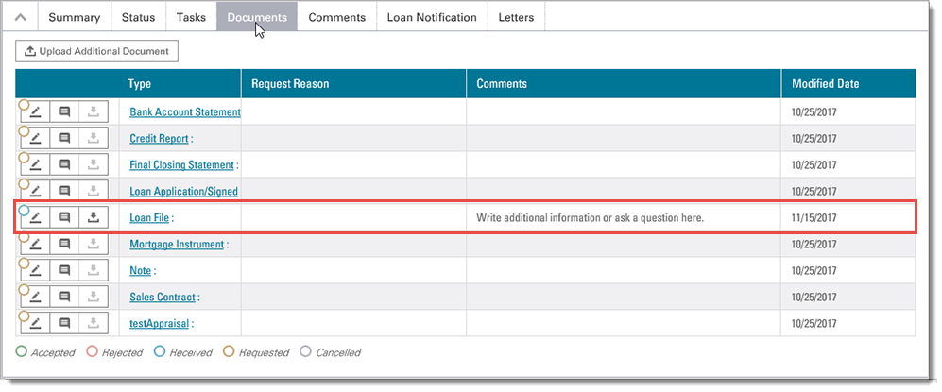

## What happens when a document is rejected by Fannie Mae?

If a document that has been uploaded is rejected by Fannie Mae, the status circle displays as red. This matches the color code for *Rejected* status.  
  
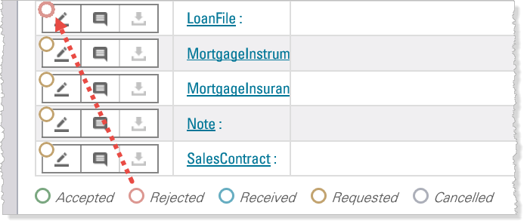

When a document is rejected, the reviewer adds a comment in Loan Quality Connect describing the reason it is unacceptable. The comment will appear in the Documents tab in the same row as the rejected document. You can also view it by clicking the **Comments** tab.



Back to Top

© 2018 Fannie Mae. Trademarks of Fannie Mae.